Mantid
Governance Model

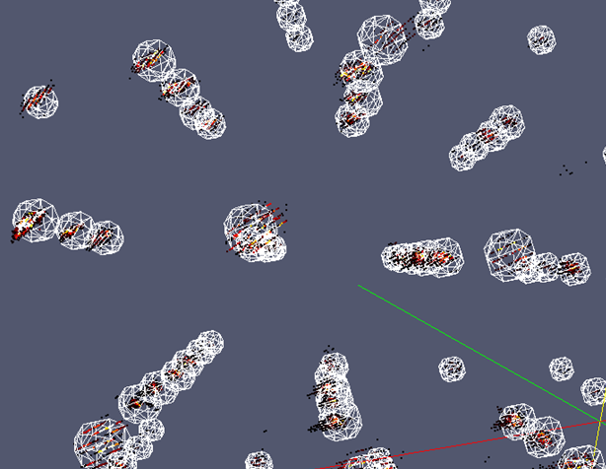
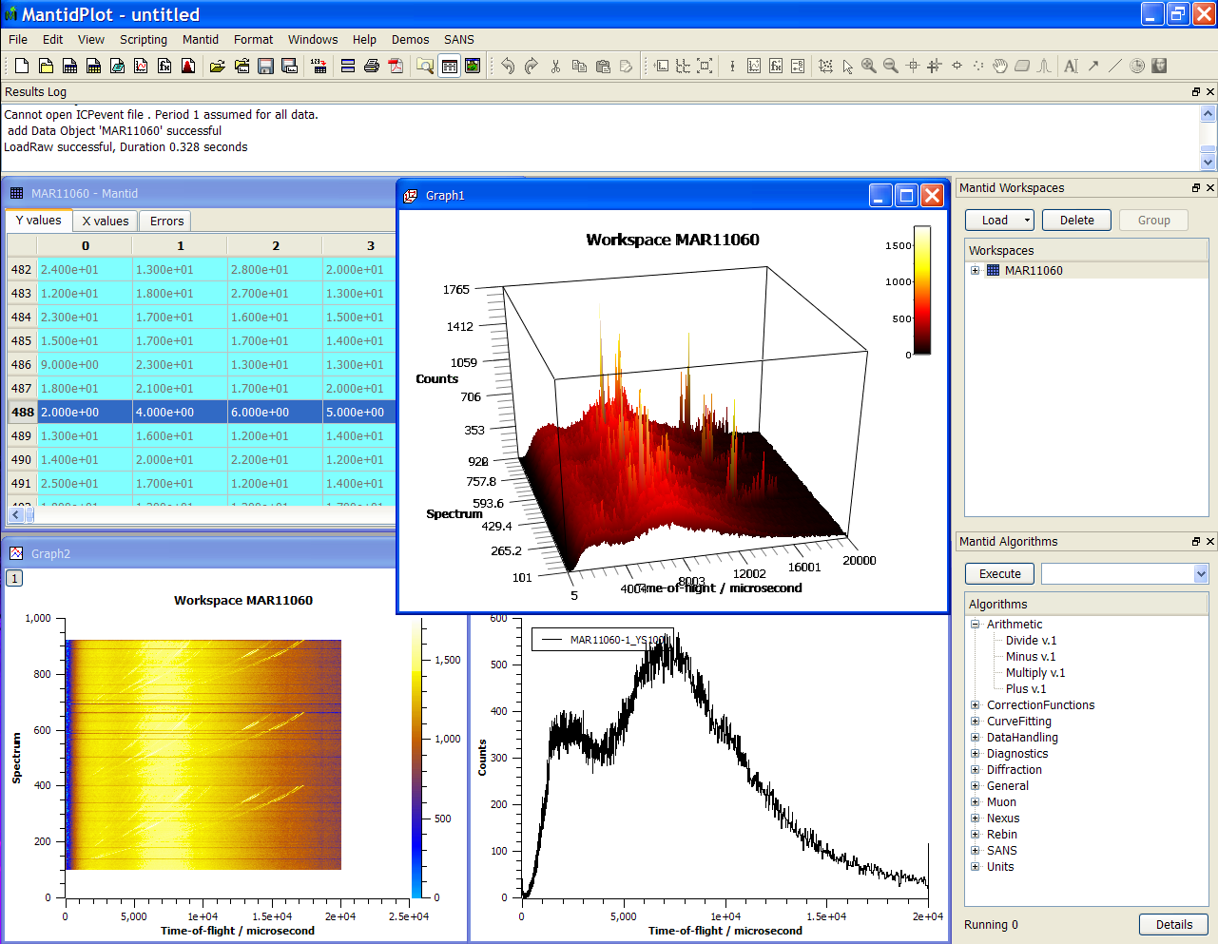

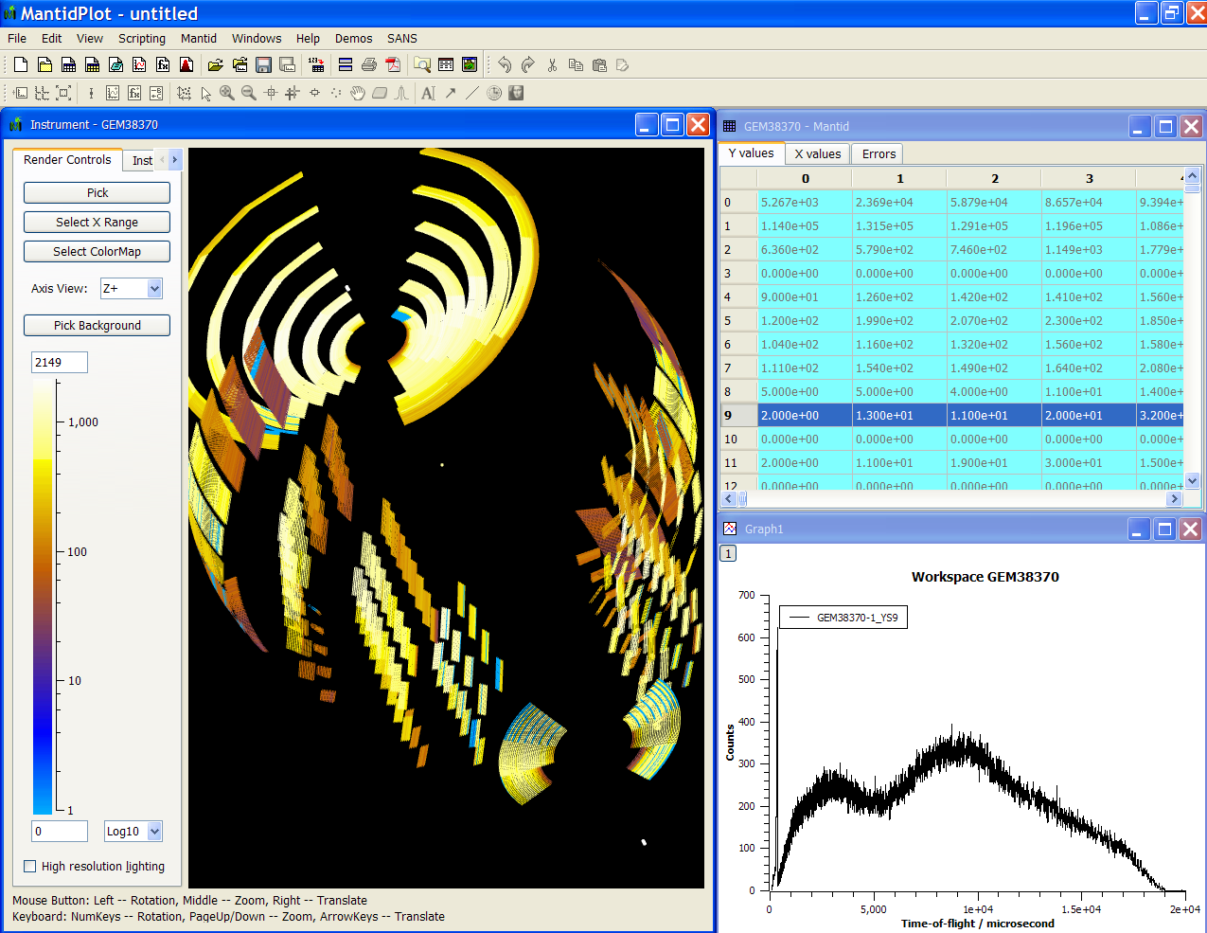
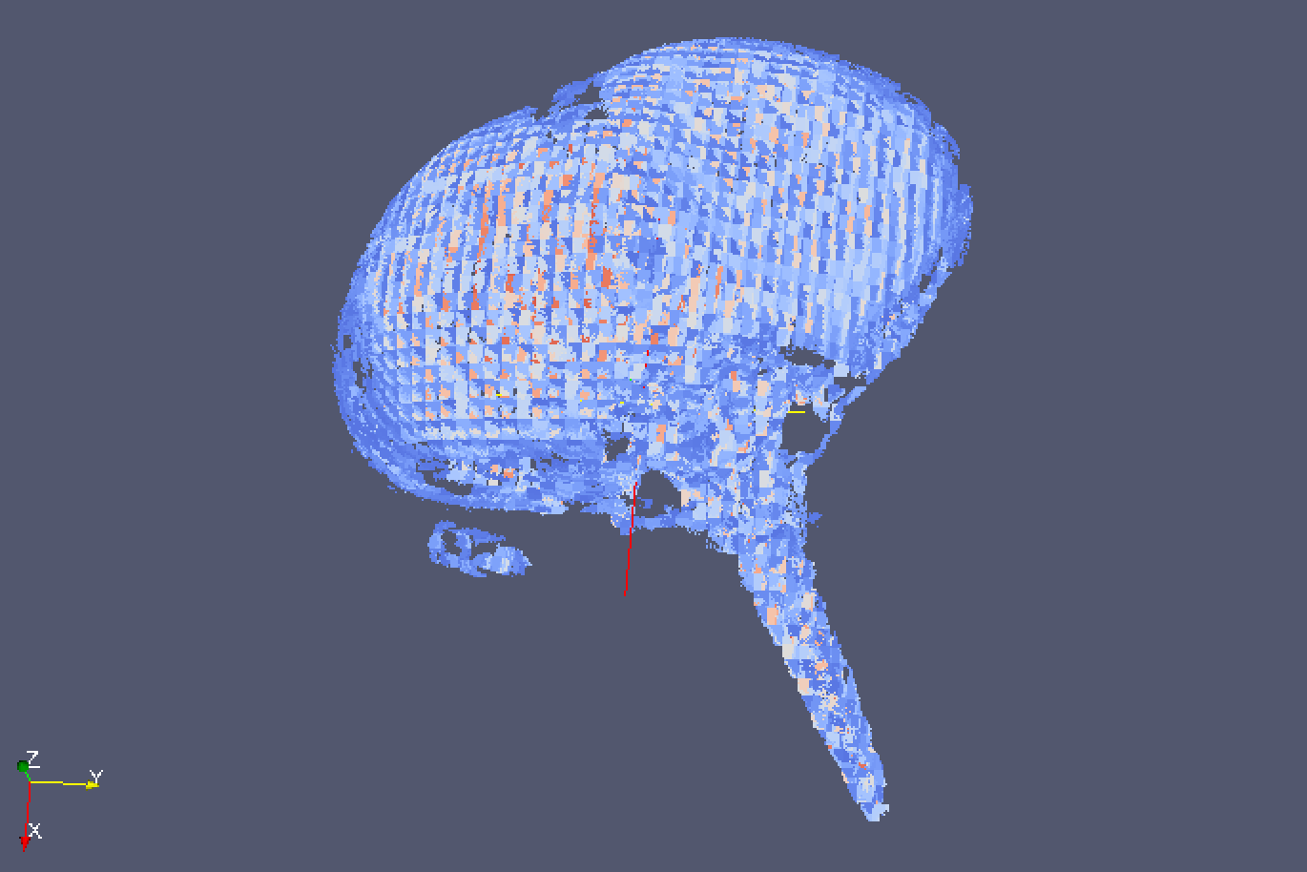

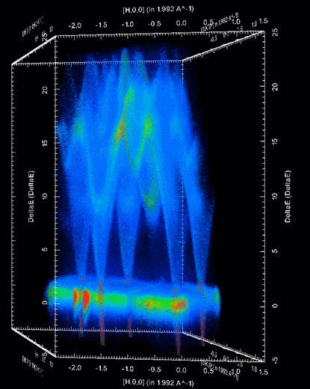
Document Control
This document is under document control. All members of the distribution list will receive updated copies whenever alterations are made. All other copies are uncontrolled.
Contributors
Name | Role | Company
Nicholas Draper | Author | Tessella, on behalf of STFC
Document Approval
Name | Role | Company
Thomas Proffen | Chair of the PMB | ORNL
Distribution
Name | Role | Company
Project Management Board Members | Recipient | STFC & ORNL
Mantid Project Repository | Filing | All Members
Revision History
Author | Issue | Date | Description
Nicholas Draper | V1.R1.M0 | 26-Sep-2013 | 1st version written
Nicholas Draper | V2.R1.M0 | 12-Feb-2014 | Adjusted to referrer solely to the Mantid project, as discussed in the January 2014 PMB..
Nicholas Draper | V2.R1.M1 | 20-Feb-2014 | Adjusted after feedback from PMB members.
Nicholas Draper | V2.R2.M2 | 31-Mar-2014 | Added details on subcontractors, the TSC and the Project Manager Role.
Nicholas Draper | V2.R3.M0 | 04-Mar-2014 | Updated after discussion at the PMB.
References
Document | Ref | Date | Details and Version
Report on Open Source Governance Models | [OSGM] | 11-Jan-2013 | https://github.com/mantidproject/documents/blob/master/Project%20Management/PMB/Report%20on%20Open%20Source%20Governance%20Models.doc?raw=true
Memorandum of understanding between ISIS and NScD | [MOU] |  | http://github.com/mantidproject/documents/blob/master/Project%20Management/Collaborations/ORNL/Appendix%201%20to%20MOU-UTB-2006223%20-%20Rev2.docx?raw=true
Technical Steering Committee Terms of Reference | [TSC Terms] |  | https://github.com/mantidproject/documents/blob/master/Project%20Management/TechnicalSteeringCommittee/TSC-Terms.md

Table of Contents
1 Introduction 3
1.1 Purpose of this Document 3
1.2 Scope of this Document 3
1.3 Context of this Issue 3
2 Mantid governance model 4
2.1 Members and Contributors 4
2.2 Mantid Project Membership Terms 5
2.3 Project Management 6
2.4 Project Management Board 6
2.5 Membership agreements 8

Introduction

Purpose of this Document
This document proposes a model for the governance of the Mantid project. The previous Mantid governance approach would struggle to expand beyond the two initial facilities, as detailed in the Report on open Source Governance Models [OSGM].

Scope of this Document
The scope of this document is to propose a governance structure for the Mantid project allowing for greater scope to scale the project beyond two collaborators.

Context of this Issue
This is the fourth draft of this report for consideration by project management board members. If approved this will form the basis of the governance structure for the Mantid project.

Mantid governance model
The Mantid project is a voluntary association made up of its members, for the development support and promotion of the Mantid project.

Members and Contributors
The Mantid project may want to collaborate with groups who are not willing or able to abide by the membership agreements. For the purposes of this document those parties contributing to the project who have agreed to the membership agreements are referred to as members, and those that have not are referred to as contributors. There rights within the association and projects will be as follows.
Individual selected developers may be offered a higher level of access as a result of a history of good quality contributions; this is at the discretion of the TSC and may be withdrawn if quality standards and practices are not followed. Granting individual developers direct access does not infer any further rights of copyright or representation to their institution.
 | Contributors | Selected Developers | Members
Representation on the Project Managing Board | No | No | Yes, the number of seats will depend on the project and the level of contribution.
User Support from other members | Goodwill support only | Goodwill support only | Best efforts as second line behind local support
Access to the development team | Yes, via defined channels | Unrestricted access | Unrestricted access
Representation at the Scientific Steering Committee or Technical Standards Committee | By invitation only | By invitation only | Yes
Attend developer meetings | By invitation only | Yes | Yes
Able to contribute code, documentation etc | Yes, via the development team. | Yes, direct access | Yes, direct access

Mantid Project Membership Terms
- The project should be developed as a single software development, separate forks of the software for individual members are not allowed unless explicitly approved by the PMB.
- Mantid is an open source project developed and released under the GNU General Public License as published by the Free Software Foundation; either version 3 of the License, or any later version. (License conditions are available at http://www.gnu.org/licenses/).
- All current members of the Mantid project should hold shared copyright over any new content created as part of the project.
- The project should have a proper project management structure:
  - There will be a single Mantid project manager, though facilities may appoint local managers of their activities which will report to the Mantid project manager.
  - A Project Management Board (PMB), which should include representatives of all members and the project manager, should meet on a regular basis to review the project status and develop implementation and release strategy, resources required and allocated etc. The chairmanship of the project board should rotate between the participants on an annual basis.
  - Each member should provide representation to the Mantid Scientific Steering Committee for each of the scientific techniques. The Scientific Steering Committee will meet annually to provide medium and long term direction to the project management board.
  - Each facility will provide at least one member of the development team to sit on the Technical Standards Committee(TSC), The TSC operates under the [TSC Terms] terms of reference, and reports to the PMB.
  - All participants understand that the maintenance of standards for development, testing and documentation has a very high priority, and work will be done within the standard defined by the Technical Standards Committee.
- The Project Manager should meet with local managers on a regular basis (weekly) to agree the distribution of work and monitor its progress, within the long term framework agreed by the project board.
- Each member will support the travel requirements of this project, specifically sending members of the Scientific Steering Committee, PMB and a proportion of the development team to the annual meetings of the various groups.
- Each member should allocate a level of resources commensurate with their expected level of deployment and development of the software. Each member should support the development of the core framework and basic analysis and visualisation capabilities, as well as the scientifically specific parts.
  - Facilities may choose to subcontract some all or none of this resource
    - Subcontractors are considered as a resource of the member that contracts them.
    - Subcontractors may hold any position within the project as assigned to them by the member that contracts them.
    - Subcontractors themselves or their companies hold no rights of membership, or copyright ownership.
- Each member should in the first instance provide user support locally. This is in any case advisable because each member should have an in-depth knowledge of the software. Best efforts should be made to provide mutual support, especially where local knowledge is lacking. Help desks should be set up for this purpose.
- A consistent method for citing the project and deliverables should be used by the Participants.
- Each member acknowledges that any confidential information obtained from, or relating to, any other member remains the property of that other and will treat such information as confidential. Confidential information should only be disclosed to a third party with the prior written consent of the other member. Each member may disclose the confidential information pursuant to a statutory obligation, an order of a court of competent jurisdiction, or the requirement of a competent regulatory body, provided that it notifies the other member as soon as the requirement to notify arises and will use its reasonable endeavours to minimise the extent of such disclosure and, where possible, to ensure the continued confidentiality of the confidential information so disclosed.

Project Management
The project manager of Mantid provides a definite decision making point for clarity and conflict resolution for routine decisions, and holds the following areas of responsibility:
- Managing the project development methodology
- Managing the project stakeholders
- Managing communication
- Managing the project team
- Managing the project risk
- Managing the project schedule
- Managing the project budgets, where appropriate.
- Managing the project conflicts
- Managing the project delivery
The project manager may work with local managers and the Technical Steering Committee, to deliver the effective management of the project. The project manager reports to the Project Management Board, and needs to consider the needs of all member facilities to successfully manage the project.

Changes to the Project Manager
The project manager is an important position to all member facilities’ as they need to take into consideration the needs of each facility in the management of the project. In addition changes within this role have the potential to be disruptive to all stakeholders, so due consideration must be taken in selecting candidates for this role.

Appointing a Project Manager
In the event that the project manager role becomes empty, it is the immediate responsibility of the chairperson of the project management board to appoint an interim project manager, to maintain the direction of the project while a suitable replacement is appointed. The identification of a suitable replacement Project Manager should be considered
In the search for a replacement Project Manager all members of the project may propose candidates for the position. Each facility is responsible for initial interviewing and selection of candidates to propose to the PMB. The PMB members may choose to hold another interview of all proposed candidates. To appoint a new project Manager the PMB must vote and achieve a 75% majority.

Removing a Project Manager
A project manager may leave the post on request, or as a result of the facility funding the Project Manager choosing to remove the Project Manager from the project. In both cases a suitable period of notice should be agreed with the PMB. The impact of such a change to the project should be considered in all decisions.
Should a project manager be considered to be failing to carry out their responsibilities adequately, a member of the PMB may propose a request to remove the project manager in writing to the Chairperson of the PMB. The chairperson will then follow the process in section 2.4.2.

Project Management Board
The Mantid project is overseen by a Project Management Board, which includes the project manager together with representative senior users and managers from the facilities involved in the collaboration. The project manager’s role within the Project Management Board is to report on plans, progress and risk management to the board and propose and advise on the impact of suggested changes, but the project manager does not hold a vote where voting is required. Other people such as a secretary, the chair of the Technical Standards Committee and the Scientific Steering Committee, or subject matter experts may be invited to attend Project Management Board meetings, but will also not have voting rights.
Chairmanship of the Project Management Board should rotate annually between its members with the restriction that the project manager cannot also be the chairperson of the PMB. The number of seats for each participating group or facility will normally be between 1 and 3 and will depend on the relative levels of contribution to the Mantid project. The discussion of relative contribution levels will occur annually at the same meeting as a new chairperson is appointed, but will be led by the departing chairperson.
Members of the Mantid PMB should be endorsed, by their respective facility director, to make decisions for the facility, with respect to the Mantid project. The project manager will store records of the endorsements.
The PMB are responsible for:
- Setting the membership terms for the project
- Approving any changes to the membership of the project.
- Championing the project and raising awareness at senior level.
- Approving strategies, implementation plan, project scope and milestones.
- Resolving strategic and policy issues.
- Prioritising project goals with other on-going projects.
- Communicating with other key organisational representatives.
- Resolving conflicts that are escalated to them.

Quorum and Voting
Meetings of the Project Management Board require a minimum membership in order to make judgements and conduct the business of the Mantid Project. For the Mantid project the minimum membership at a meeting is defined as one member of each group or facility, plus the chair of the PMB.
For all aspects that require a vote all members must vote before a decision can be made. The Chairperson of the board is responsible for informing members not present at the meeting and gathering their votes.

Resolving serious complaints
This process may be used to assess the validity of complaints about any member of the PMB (including the PM, or Chairperson), or a facility of group as a member of the project. This is a process for serious complaint that might result in that person or group leaving the Mantid Project.
- Any member of the project may raise a complaint in writing to the Chairperson of the PMB. In the event that the complaint is regarding the Chairperson then the Project Manager will take over the Chairperson’s role for this procedure.
- The Chairperson will investigate the complaint, and may dismiss requests that are similar to previous complaint within the previous year.
- The Chairperson will share the complaint with the PMB voting members (excluding any of those directly involved) and if supported by 50% of those members will trigger an emergency meeting of the PMB. Discussion up to this point must be confidential and not be shared outside of those PMB voting members.
- The Chairperson will write to the parties involved, explaining the complaint, and inviting those involved and optionally an additional representative to the emergency meeting of the PMB, which should be held at least 1 and not more than 3 weeks from receipt of the communication.
- At the emergency PMB the member who raised the concern, and the parties involved will state their cases, and then withdraw from the meeting. A vote of 75% of the remaining voting members is required to remove the parties involved from their role within the project.
- Any request to appeal a membership decision this must be submitted to the Chair of the PMB within one calendar month of the decision. Any appeals must be discussed at the next PMB meeting, and a vote of 75% is required to overturn the previous decision.

Membership agreements
Each participating member facility or group in the Mantid project must agree to abide by the membership terms of the project as defined in section 2.2. The agreement will be between the contributing facility and the Mantid project. As the voluntary association itself is not a legal entity these agreements would not be legally enforceable, but would be an agreement based on trust.

Joining the Mantid project
Any prospective groups or facilities who wish to join the project and are willing to abide by the project terms may request membership by contacting the Chair of the Mantid project management board. This contact should be from the Director or Head of the group or facility and should include:
- Acceptance of the Mantid Project Membership Terms, see section 2.2
- A high level roadmap covering what they intend to achieve within the Mantid project
- A statement of the resources they plan to contribute to the project to achieve their goals and provide ongoing support for their facility or group.
If any help is required in creating a roadmap or statement of resources, please contact the project manager. Requests for membership will be voted on at the next PMB meeting; new members are approved by a 75% vote (with the chairperson holding a casting vote in the event of a tie). If any member or the prospective member wishes to appeal a membership decision this must be submitted to the Chair of the Mantid PMB within one calendar month of the decision.

Leaving the Mantid project
Members may choose to leave the project without prior notice. The Director or Head or the member facility or group should inform the Chair of the PMB to notify them of the withdrawal of their facility or group from the project.
If a member of a project is perceived not to be fulfilling their agreement then this may be raised in writing by a member of the PMB to the Chair of the Project Management Board, which will follow the process in section 2.4.2.

Changes to the Project Terms or Governance Model
Changes to the Mantid project Terms or Governance Model defined in this document may be suggested and discussed at a meeting of the PMB. A vote of 75% of the voting members is required to agree any change.
Any significant change to the membership terms on section 2.2 would require all existing members to reaffirm their acceptance to those terms.

